In order to set up a local network adapter, we must begin with adding a network adapter by clicking “Edit virtual machine settings” > “Add..” > “Network adapter”.

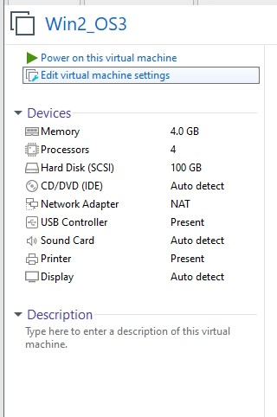

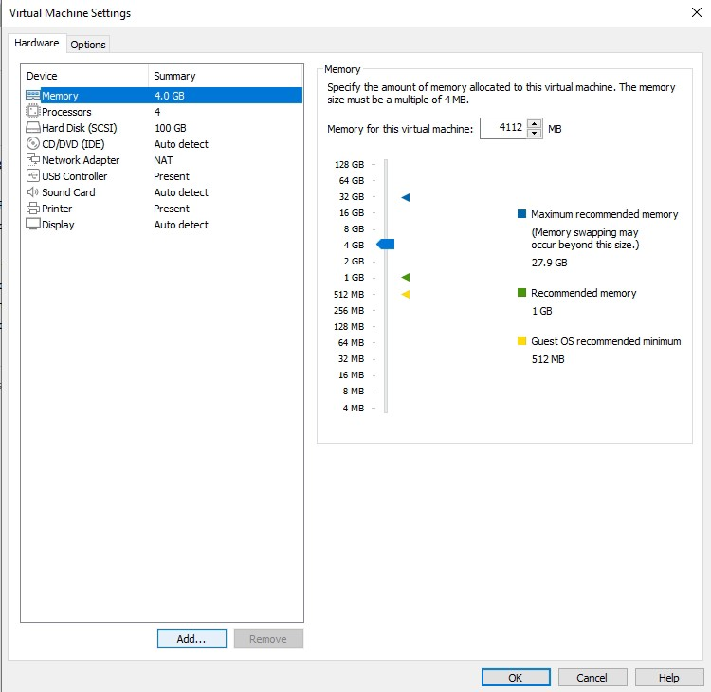

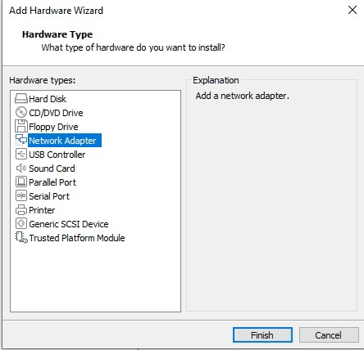

Then we configure the newly-added network adapter. To accomplish this, we go to “Network adapter” > “LAN Segments” > “Security” (It’s the name given to the first machine by us, moreover you may choose your own custom name to be used for the first machine.)

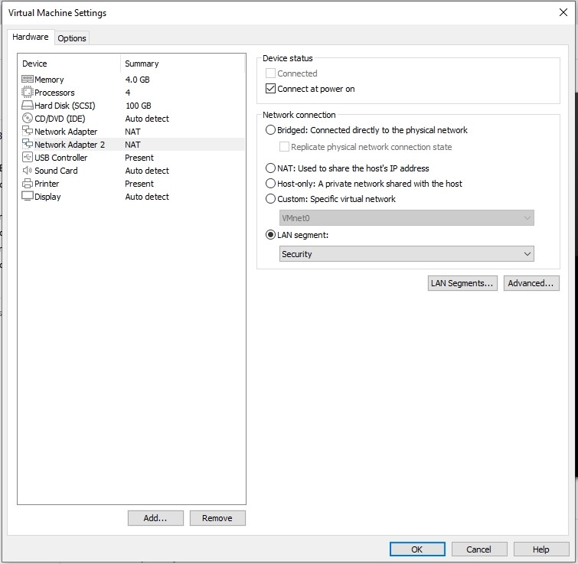

Next we run the virtual machine and launch the terminal via the root user.

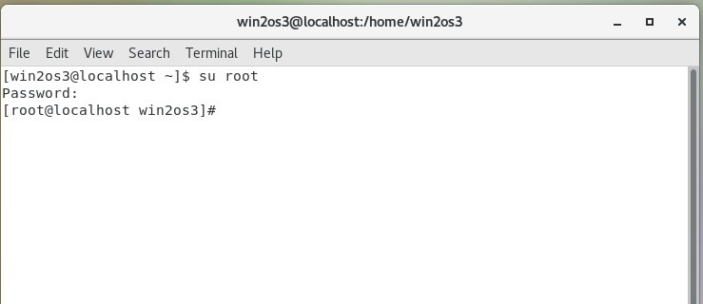

In order to test our newly-configured network, it is advised to check to which networks our device is connected by means of the “nmcli d” command.

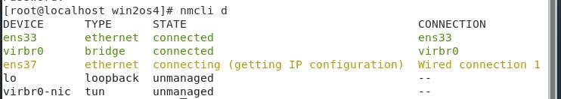

Here we can clearly see that our network adapter is under the name “ens37” or “Wired connection 1”.

We begin by creating a network adapter. To go to the “network-scripts” folder enter:

cd /etc/sysconfig/network-scripts/

ls

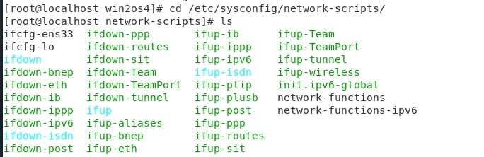

We should notice that there is a configuration file for the “ens33” network adapter under the name “ifcfg-ens33”; however, what we need is the configuration file for the “ens37” network adapter, thus, It must be created by us. First, we generate uuid for our network adapter with the “uuidgen ens37” command and copy it to the clipboard.



Then we copy the “ifcfg-ens33” file and name it “ifcfg-ens37” by entering:

cp ifcfg-ens33 ifcfg-ens37

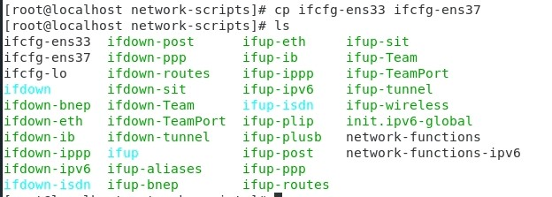

Now, we open the file:

vi ifcfg-ens37



By pressing the Insert key we start editing the file. We paste the previously copied uuid instead of UUID. The NAME is changed from ens33 to ens37, whereas the same is done with DEVICE.

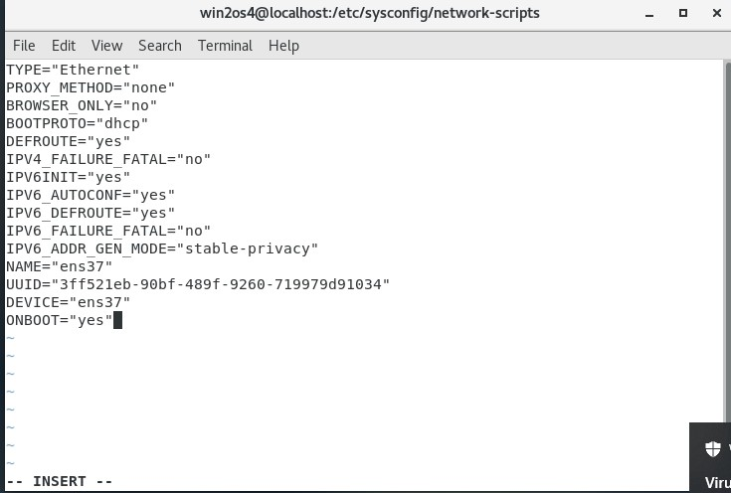

We press “Esc” and enter “:wq!”. Then we press “Enter”.

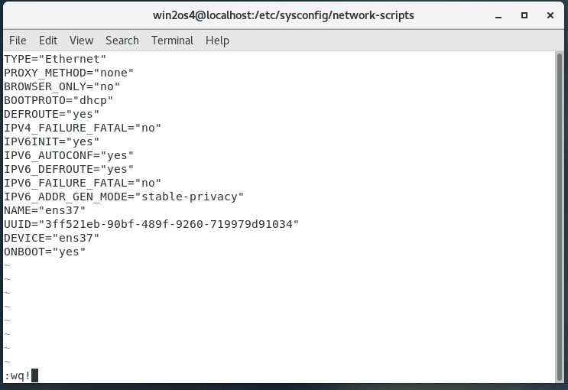

Now we restart the network with:

systemctl restart network



We move on to network adapter configuration by entering:

nmtui



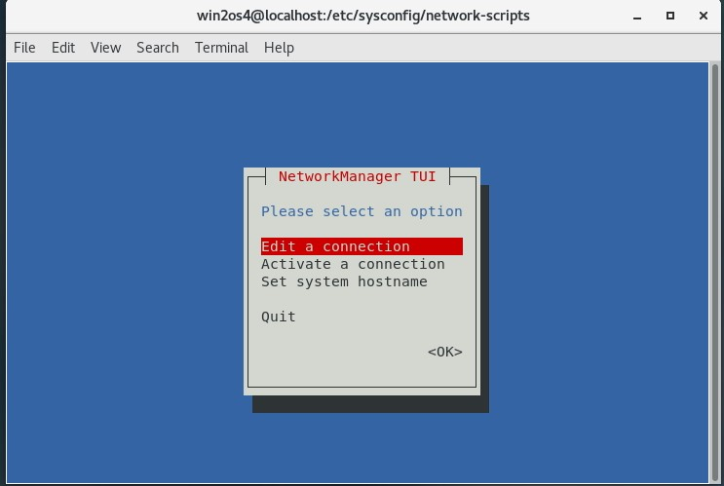

We choose “Edit a connection”

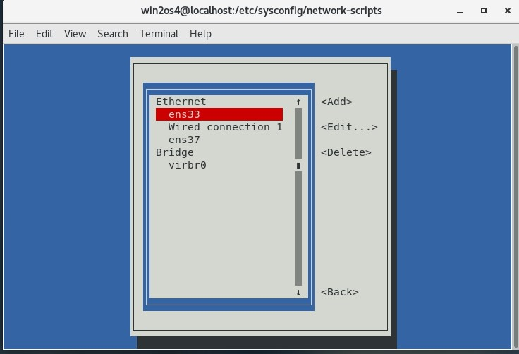

A window appears where we first edit the “Wired connection 1”

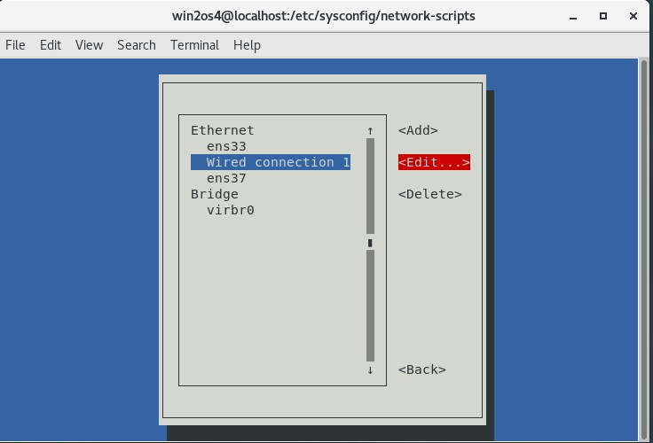

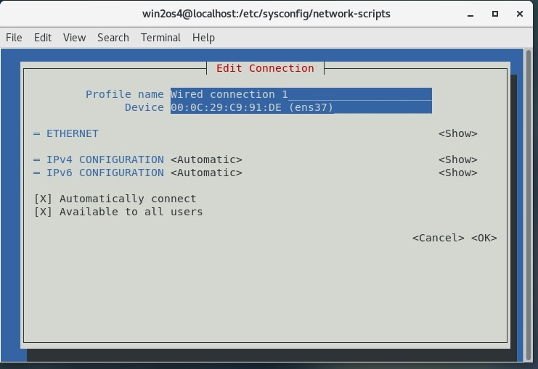

We move to the IPv4 CONFIGURATION line and choose <Manual >instead of <Automatic>

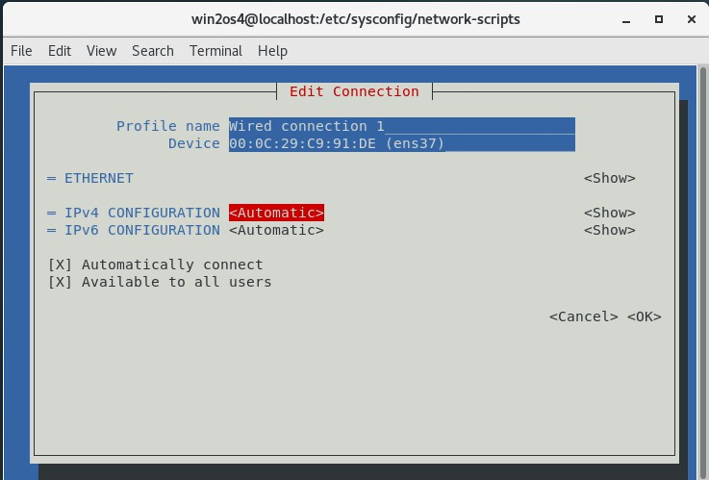

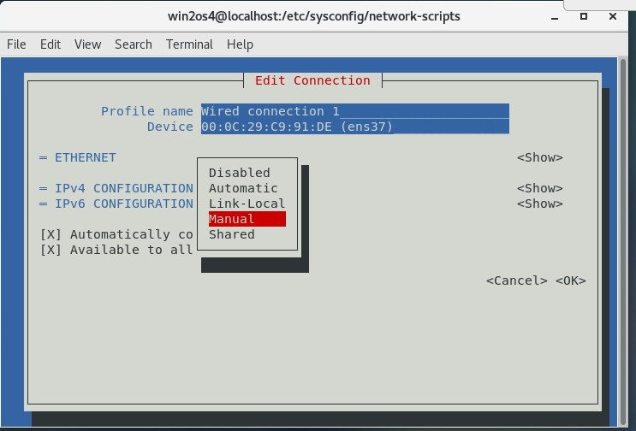

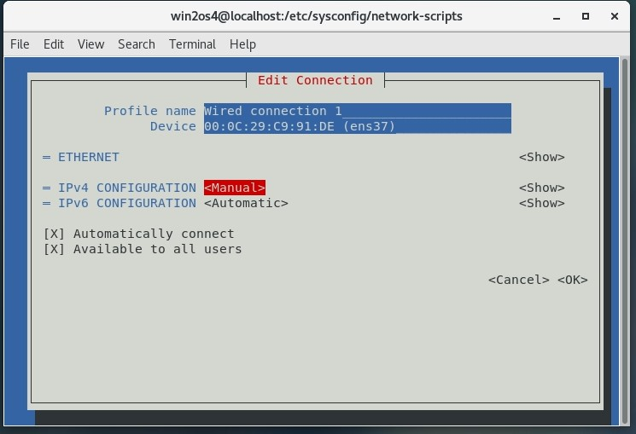

We move to “Show” and configure the network.

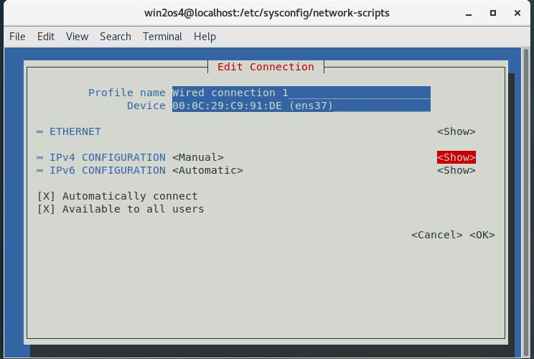

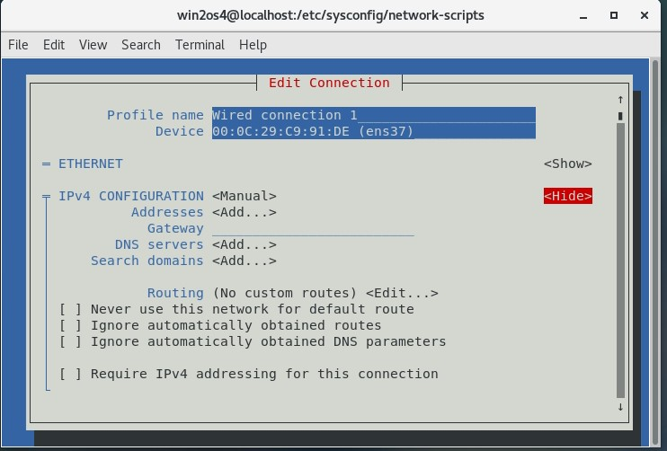

We enter an arbitrary IP address into the “Addresses” line, in our case it’s “55.1.55.9/24”, then enter “8.8.8.8” into the “DNS servers” line. Also, we make sure to check “Require IPv4 addressing for this connection”.

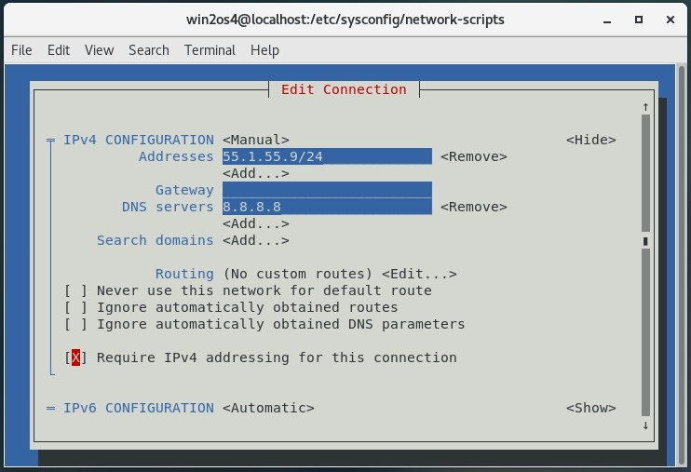

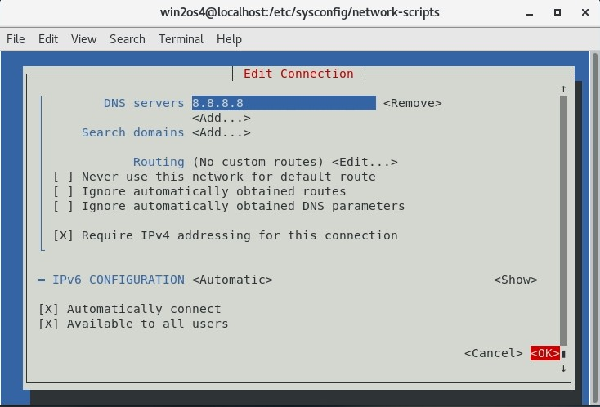

Now we do the same for ens37.

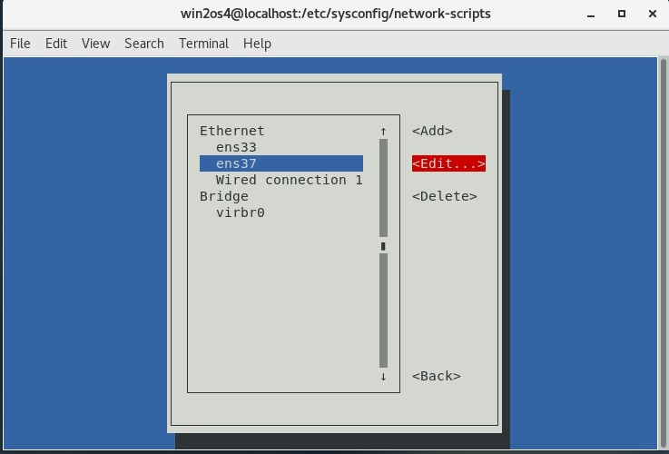

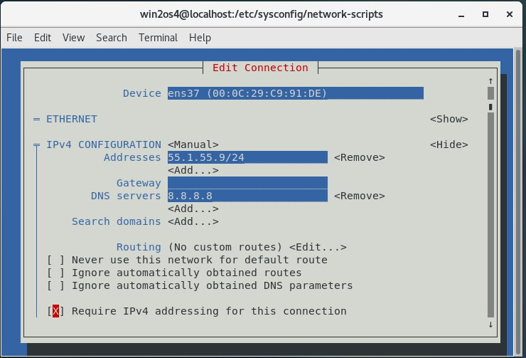

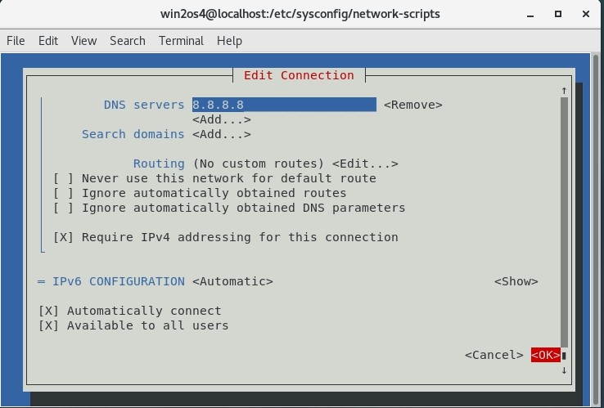

Now we exit network configuration.

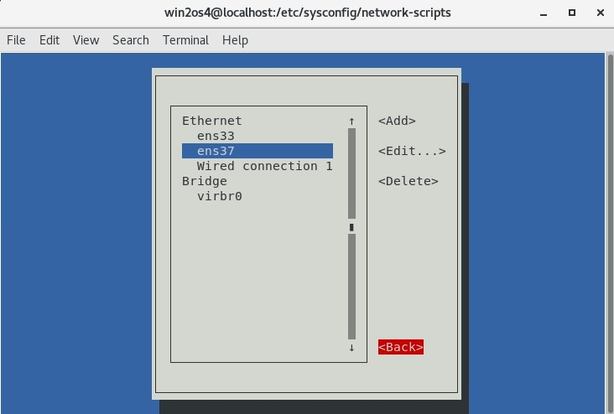

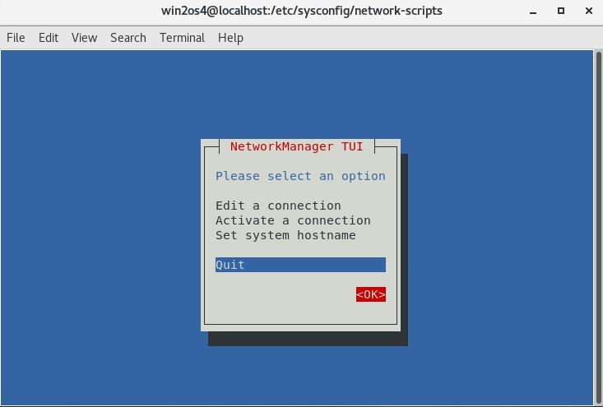

We restart the network again by entering:

systemctl restart network



Finally, we test the connection to the previously set IP addresses.

